IBM ASSIGNMENT – 1

| Team ID | PNT2022TMID50829 |
| --- | --- |
| Project Name | REAL -TIME RIVER WATER QUALITY MONITORING AND CONTROL SYSTEM |

**Thinkercad with 2 sensors, an,Led, buzzer :**

Let's learn how to control multiple LEDs using Arduino’s digital outputs and a breadboard. Expanding upon the [last lesson on blinking an LED](https://www.instructables.com/id/Blink-an-LED-With-Arduino-in-Tinkercad/), We'll

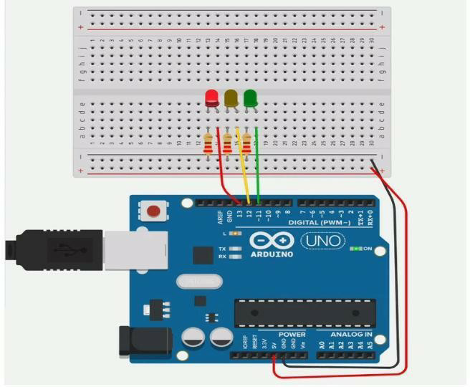

connect some LEDs to the Arduino Uno and compose a simple program to light them up in a pattern.

You can follow along virtually using [Tinkercad Circuits](https://www.tinkercad.com/circuits). You can even [view this lesson from within Tinkercad](https://www.tinkercad.com/things/newv2?tenant=circuits&lessonid=ELB4FYAJD0K8TZV&projectid=O6QUTPNJDUKI7RD&collectionid=OMOZACHJ9IR8LRE&title=Multiple%20LEDs%20&%20Breadboards) if you like! Explore the sample circuit and build your own right next to it! Explore the sample circuit in the workplane, and build your own along side it. Tinkercad Circuits is a free browser-based program that lets you build and simulate circuits. It's perfect for [learning](https://www.tinkercad.com/learn/), [teaching](https://www.tinkercad.com/teach), and prototyping.

Program:

#include <SoftwareSerial.h>

#include<A7Client.h>

A7Client a7Client (7, 8); // RX, TX on Uno, connected to Tx, Rx of A7 Module

const char server[] = "waterqualitysite.azurewebsites.net";

//char message[] = "GET /log.php?t=2016-10-25,21:16:00&te=30.0&do=7.05&pH=5.66&tu=7&la=5.1492&ln=100.492 HTTP/1.1\r\nHost: waterqualitysite.azurewebsites.net\r\nConnection: close\r\n\r\n";

char msg[200] = "";

// char time[] = "2016-11-18,22:35:01";

char temperature[7] = "";//-30.00

char pH[6] = "";//14.00

char DO[7] = ""; //100.00%

char turbidity[5] = "";//4000

char lat[9] = "";

char lng[9] = "";

const uint8_t pinRST = 5;

const uint8_t pinPWR = 6;

const uint8_t pinTurbidity = A0;

const uint8_t pinPH = A1;

const uint8_t pinDO = A2;

const uint8_t pinTemperature = A3;

struct Data{

float temperature;

float pH;

float DO;

int turbidity;

} data;

unsigned long previousMillis = 0; //for looping purpose

long timeInterval = 10000; //update once per 10 seconds

void setup() {

Serial.begin(9600);

Serial.println(freeRam());

pinMode(13, OUTPUT);

digitalWrite(13, LOW); //disable the bright RED LED!

pinMode(pinRST, OUTPUT);

pinMode(pinPWR, OUTPUT);

digitalWrite(pinRST, HIGH);//reset the A7 module

delay(1000);

digitalWrite(pinRST, LOW);//finish the reset

digitalWrite(pinPWR, LOW);//POWER UP the A7 module via a PNP transistor

delay(2000); //need to apply power to the pin for >2 seconds

digitalWrite(pinPWR, HIGH);//finish the power up

delay(3500);//let the module stable, it will output some gibberish.

a7Client.changeBaud();//Baud rate for A7.serial is now at 9600 bps

Serial.println(freeRam());

Serial.println(F("Response okay! :) Module is alive!"));

delay(10000); //wait for the config message for GPRS and everything

while(!a7Client.startGPS()){// make sure GPS is on

Serial.println(F("Try activating GPS again."));

}

// a7Client.startGPS();

getData(&data);

printData(&data);

while(!a7Client.readGPS());//force Arduino to complete one GPS at least once =.= 16/11/16

if(a7Client.parse(a7Client.lastNMEA())){

// Serial.print(F("Location: "));

// Serial.print(a7Client.latitude, 4); Serial.print(a7Client.lat);

// Serial.print(F(", "));

// Serial.print(a7Client.longitude, 4); Serial.println(a7Client.lon);

// Serial.print(F("Location (in degrees, works with Google Maps): "));

// Serial.print(a7Client.latitudeDegrees, 4);

// Serial.print(F(", "));

// Serial.println(a7Client.longitudeDegrees, 4);

}

//force the GPS to be DUP if lat=0.000, 0.000

if( a7Client.latitude - 0.000 < 0.0000001){

a7Client.latitude = 5.356575;

a7Client.longitude = 100.294404;

}

convertToChar(&data, a7Client);

// if (lat[0] == '0'){ //force the GPS to be DUP :)

// lat[0] = '5';

// lat[1] = '.';

// lat[2] = '3';

// lat[3] = '5';

// lat[4] = '6';

// lat[5] = '5';

// lat[6] = 0;

// lng[0] = '1';

// lng[0] = '0';

// lng[0] = '0';

// lng[0] = '.';

// lng[0] = '2';

// lng[0] = '9';

// lng[0] = '1';

// }

constructHTTPRequest(msg);

a7Client.connect(server, 80);

sendHTTPRequest(msg);

}

void loop() {

// Serial.println(F("I am down here"));

// if (a7Client.available())

// Serial.write(a7Client.read());

// if (Serial.available())

// a7Client.writeSerial(Serial.read());

//start of millis() code from AdaFruit

unsigned long currentMillis = millis();

getData(&data);

printData(&data);

if((currentMillis - previousMillis >= timeInterval)){

previousMillis = currentMillis;

getData(&data);

printData(&data);

while(!a7Client.readGPS());//force Arduino to complete one GPS at least once =.= 16/11/16

if(a7Client.parse(a7Client.lastNMEA())){

Serial.println(F("parsed completed"));

}

convertToChar(&data, a7Client);

printCharData();

constructHTTPRequest(msg);

if (a7Client.connect(server, 80)){

digitalWrite(13, HIGH);

delay(500); //blink LED13

digitalWrite(13, LOW);

}

sendHTTPRequest(msg);

}

}